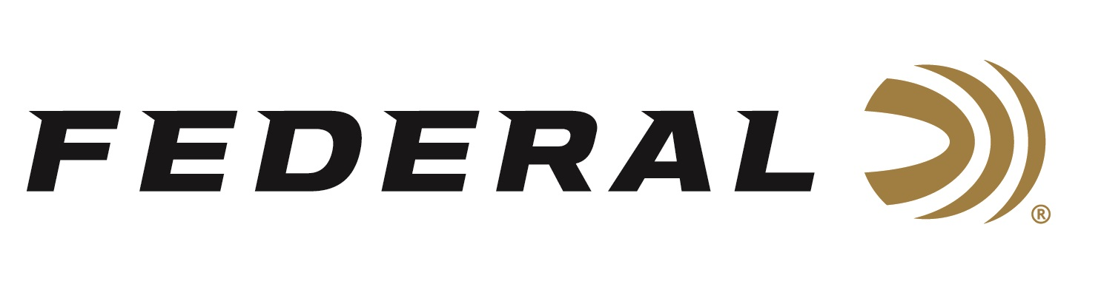

FOR IMMEDIATE RELEASE

It’s Never Too Late on the “It’s Federal Season” Podcast

ANOKA, Minnesota – August 12, 2021 – Ava Flanell, Federal’s newest ambassador, proves the adage it’s never too late to learn something new. The certified firearm’s instructor didn’t start shooting until later in life and today, she shoots, hunts, and teaches courses on the safe handling and fun of firearms. Flanell shares her passion with new shooters having just bought their first gun to experienced shooters wanting to continuously improve their skills.

Episode #24 “It’s Never Too Late”
https://www.federalpremium.com/this-is-federal/podcast/

“Ava has a great story of switching careers midstream,” stated Jason Nash, Federal Ammunition’s Vice President of Marketing. “Her story is inspiring and unique and Federal is proud to have her part of our dedicated team to bring more shooters into the outdoors,” says Nash.

In the Tech Talk segment, Flanell dives deeper into some of the course descriptions and what she hopes her students to leave with after completing her courses at Elite Firearms & Training in Colorado.

For this episode, besides listening on the Federal Premium website or Talk North podcast network, you can also subscribe to Federal Ammunition’s YouTube channel (https://www.youtube.com/user/federalpremiumammo) and tune in for the discussion.

Federal Ammunition can be found at dealers nationwide or purchased online direct from Federal. For more information on all products from Federal or to shop online, visit www.federalpremium.com.

Press Release Contact: JJ Reich
Senior Manager – Press Relations
E-mail: VistaPressroom@VistaOutdoor.com

About Federal Ammunition
Federal, headquartered in Anoka, MN, is a brand of Vista Outdoor Inc., an outdoor sports and recreation company. From humble beginnings nestled among the lakes and woods of Minnesota, Federal Ammunition has evolved into one of the world's largest producers of sporting ammunition. Beginning in 1922, founding president, Charles L. Horn, paved the way for our success. Today, Federal carries on Horn's vision for quality products and service with the next generation of outdoorsmen and women. We maintain our position as experts in the science of ammunition production. Every day we manufacture products to enhance our customers' shooting experience while partnering with the conservation organizations that protect and support our outdoor heritage. We offer thousands of options in our Federal Premium and Federal® lines-it's what makes us the most complete ammunition company in the business and provides our customers with a choice no matter their pursuit.

